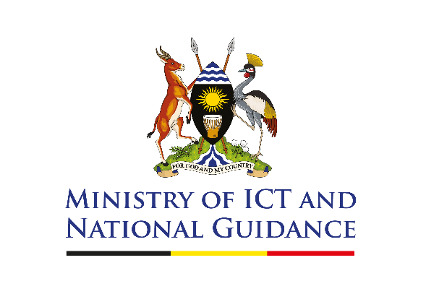

**FOR IMMEDIATE RELEASE**

**May 28th, 2025**

**Uganda Joins Global 50-in-5 Campaign to Accelerate Safe, Inclusive and Interoperable Digital Public Infrastructure**

The Government of Uganda, through the Ministry of ICT and National Guidance, is proud to announce its participation in the global 50-in-5 initiative, a collaborative effort aimed at accelerating the adoption of Digital Public Infrastructure (DPI) over five years. The initiative is being co-led by the Digital Public Goods Alliance and Co-Develop partnership with the Bill & Melinda Gates Foundation, UNDP, and other organizations committed to inclusive digital transformation.

Uganda joins a global community of countries committed to sharing best practices and experiences in building DPI. Through this initiative, Uganda will showcase how it has leveraged the data exchange platform (UG-Hub) in implementing its country-wide poverty eradication program, the Parish Development Model, which has transformed citizens' lives through creating equitable access to investment funds

“By joining the 50-in-5 campaign, Uganda strengthens its commitment to harnessing the power of digital public infrastructure to drive socio-economic development. We believe that through strategic partnerships and innovation, we can create a digitally inclusive society where every Ugandan has the opportunity to thrive,” said Hon. Joyce Nabbosa Ssebugwawo, State Minister for ICT.

Uganda’s participation in the initiative arrives in time as the country embarks on the massive implementation of the National Identity, which is being developed as a digital Public good,” said Dr. Aminah Zawedde, Permanent Secretary, Ministry of ICT and National Guidance. “We look forward to working with global partners to advance our DPI journey and ensure that every citizen benefits from inclusive, secure, and accessible digital systems.”

The 50-in-5 initiative will provide Uganda with international exposure and access to technical support, expert insights, and shared resources to fast-track the development of digital identity systems, secure data exchange, and digital payments. It also opens doors to partnerships with development agencies, donors, and technology innovators focused on building inclusive and resilient digital ecosystems.

**For More Information:**

Doreen Gift Bujjingo

ICT Infrastructure Engineer

Ministry of ICT and NG

[doreen.bujjingo@ict.go.ug](mailto:doreen.bujjingo@ict.go.ug)

Florence Mukankusi

Communication and Public Relations Expert

Ministry of ICT and NG

0783402115

**###**