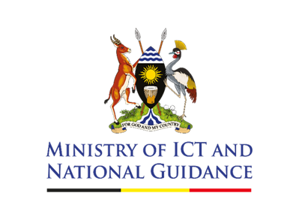
STATEMENT BY THE PERMANENT SECRETARY - MINISTRY OF ICT AND NATIONAL GUIDANCE
PRESS BRIEFING ON ELECTIONS, MEDIA RESPONSIBILITY, AND INTERNET RUMOURS – 5TH JANUARY 2026
The ED, Uganda Communications Commission
The ED, Uganda Media Centre
Media Fraternity,
Ladies and gentlemen,
Happy New Year, and Good morning,
As the country approaches the election period, public engagement has intensified, as expected in any democracy. Alongside this increased participation, however, we have also seen a rise in misinformation, particularly on digital platforms. One of the most persistent claims currently circulating is that the Government intends to switch off the internet during the elections.
The Government has not announced, directed, or implemented any decision to shut down the internet during the election period. Claims suggesting otherwise are false and misleading. Such misinformation unnecessarily creates fear, undermines public confidence, and risks heightening tension at a critical national moment.
The Ministry of ICT and National Guidance remains committed to promoting access to information, digital inclusion, and the responsible use of information and communication technologies. ICTs and media platforms play a central role in democratic participation by enabling citizens to access accurate and timely information. That role becomes even more critical during elections.
In this regard, the Ministry continues to work closely with the Uganda Communications Commission to prepare the media sector for this period. Together, we have engaged broadcasters and media stakeholders across the country to reinforce professionalism, ethical conduct, and accountability in election coverage. These efforts have been complemented by ongoing nationwide sensitisation through radio, digital platforms, and direct engagements with media practitioners.
Responsible media coverage during elections is not optional. It is essential for peace, public order, and national stability. Media platforms must not be abused to incite violence, spread falsehoods, or undermine the credibility of the electoral process. The misuse of both traditional and digital media by political actors or individuals in pursuit of narrow interests will not be tolerated.
Broadcasters and online media practitioners are reminded that live broadcasting or streaming of riots, unlawful processions, or violent incidents is prohibited, as it can escalate tensions and spread panic. The dissemination of inciting, hateful, or violent content is unlawful and attracts enforcement action. Additionally, the declaration of election results remains the sole mandate of the Electoral Commission, and the broadcasting or sharing of unverified or premature results is illegal.
Digital platforms are not exempt from the law. The Computer Misuse Act applies fully to online conduct, including the spread of false information and offensive communication. Freedom of expression must be exercised responsibly and within the framework of the law.
The Uganda Communications Commission, working with relevant stakeholders, is actively monitoring broadcast and online media. Any violations will be addressed in accordance with the law, including regulatory sanctions where necessary.
As we move closer to polling day, I urge media owners, editors, journalists, digital publishers, and the public to rely on verified information and official sources. I also call upon all citizens to act responsibly online and offline, and to reject misinformation intended to cause fear or division.
Our collective responsibility is to ensure that ICTs and the media contribute to peaceful, credible elections and national unity. Let us use these platforms in the service of truth, stability, and the public good.
For God and My Country!

Dr. Aminah Zawedde
Permanent Secretary

